These are examples of the short book descriptions on the web pages and physical books.

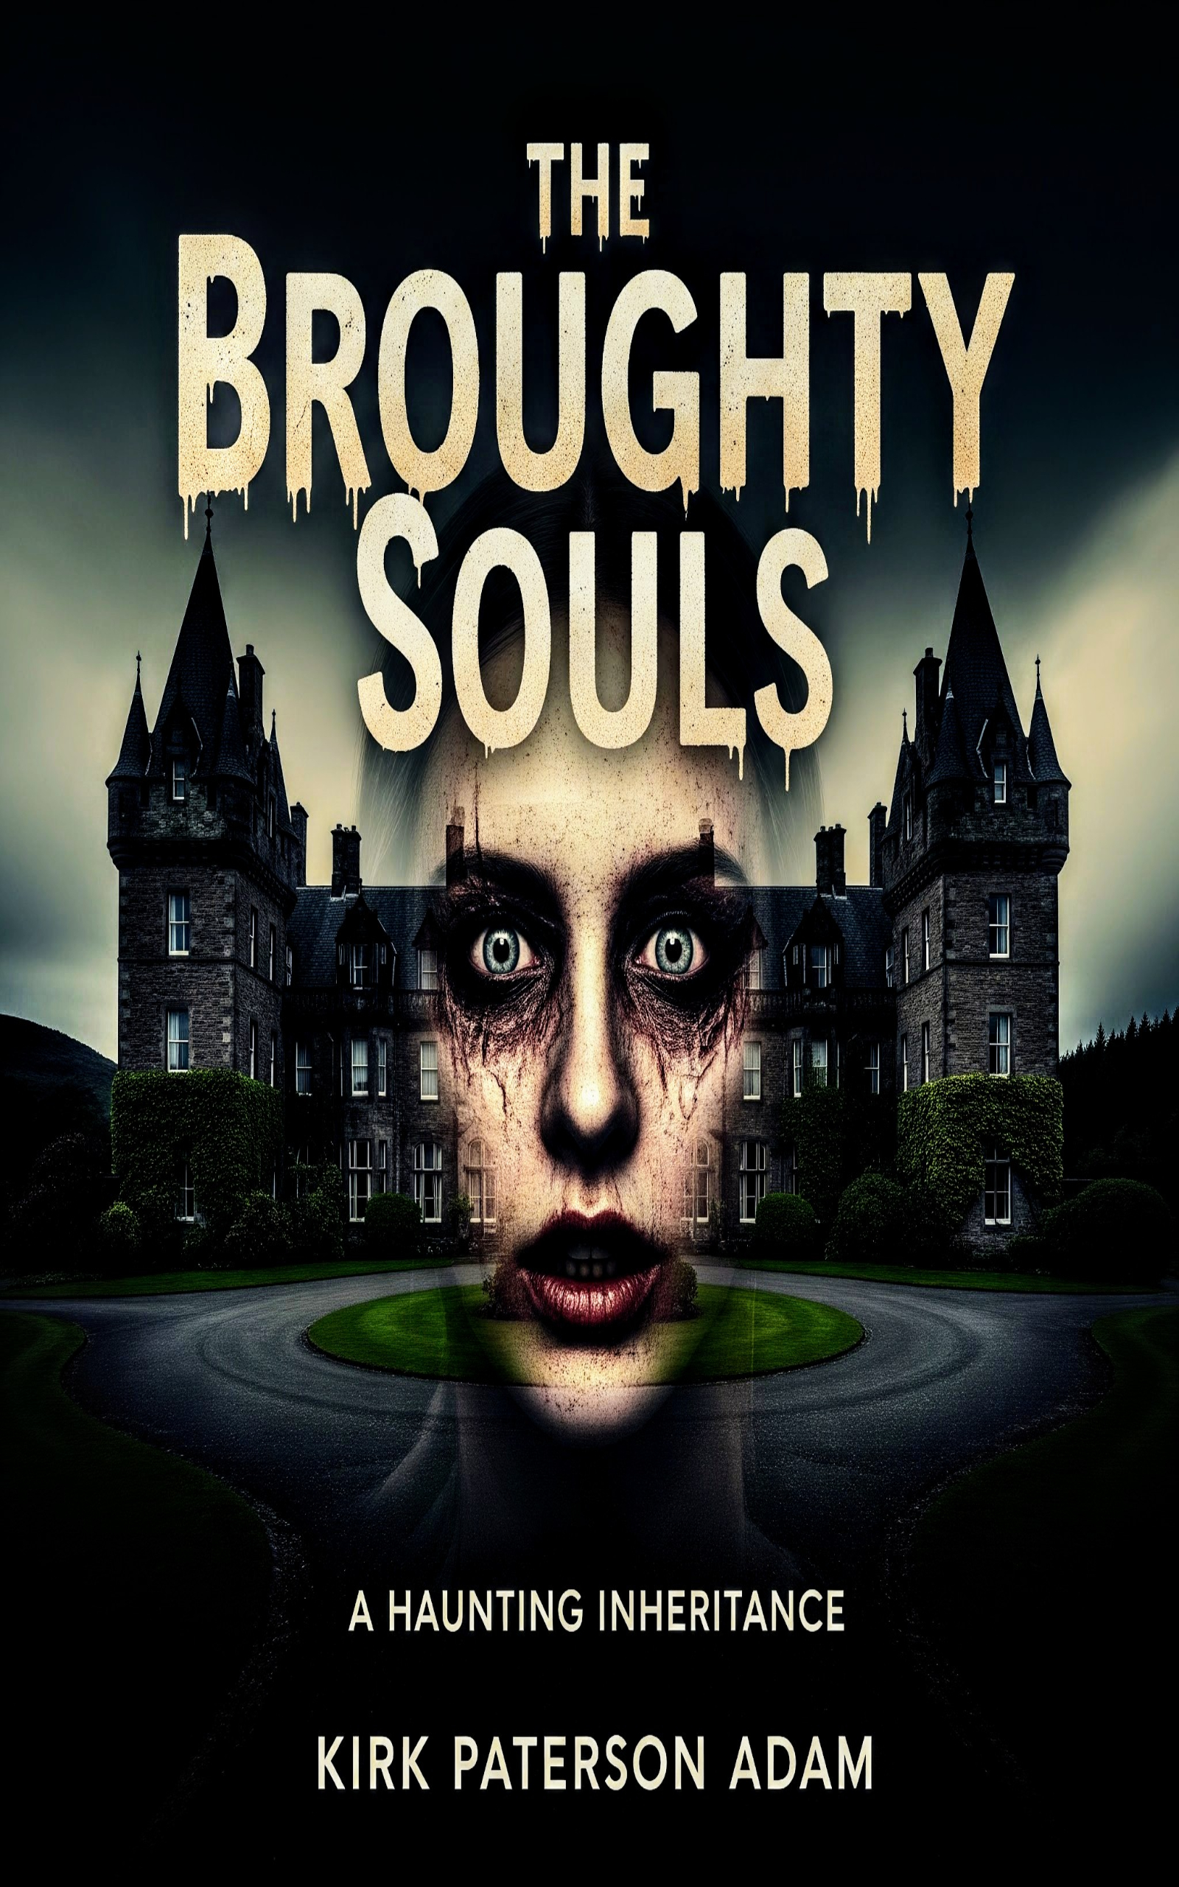The Broughty Souls:

The Dunella Hotel, a legacy, a sanctuary. Bruce arrived seeking peace and a new life, but this old Georgian building nestled in a Scottish seaside town, harbours more than just guests. Hidden rooms, forgotten rituals, and a history steeped in dread begin to surface, twisting his newfound happiness into a horrifying ordeal. He must confront the hotels dark secrets, or become another lost soul trapped within its haunted walls.

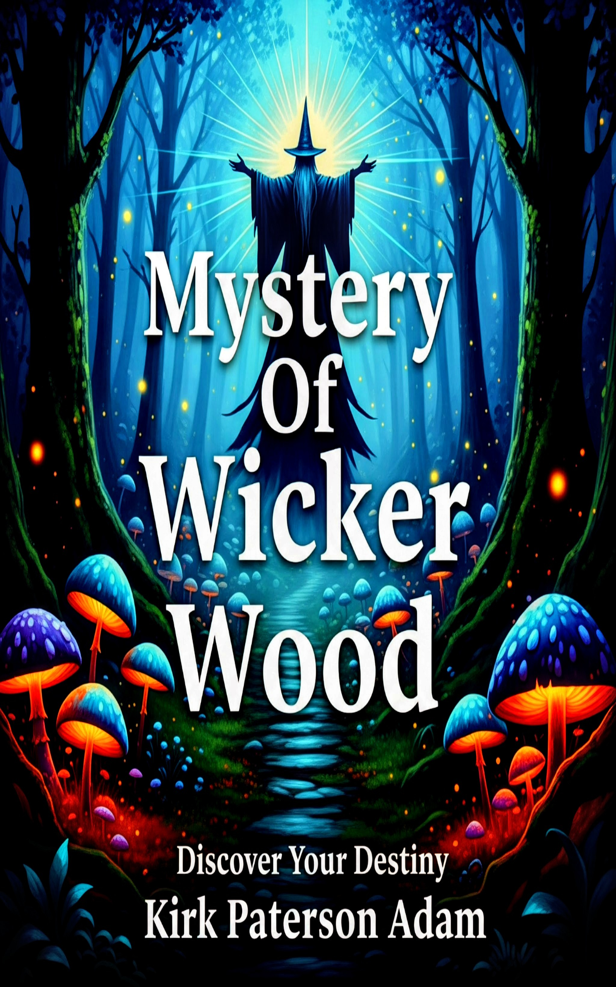Mystery Of Wicker Wood:

Fifteen-year-old Sophie's birthday venture into Wicker Wood reveals a magical subterranean world and Devona, its mysterious protector. Drawn into a time-traveling quest to prevent the theft of Merlin's spell book known as the 'Grimoire' she encounters Vikings, Saxons, and Merlin himself. As the truth emerges, Sophie learns she's destined to protect Wicker Wood but faces an unexpected final test. This spellbinding tale explores courage, destiny, and self-discovery, leaving readers feeling enchanted.

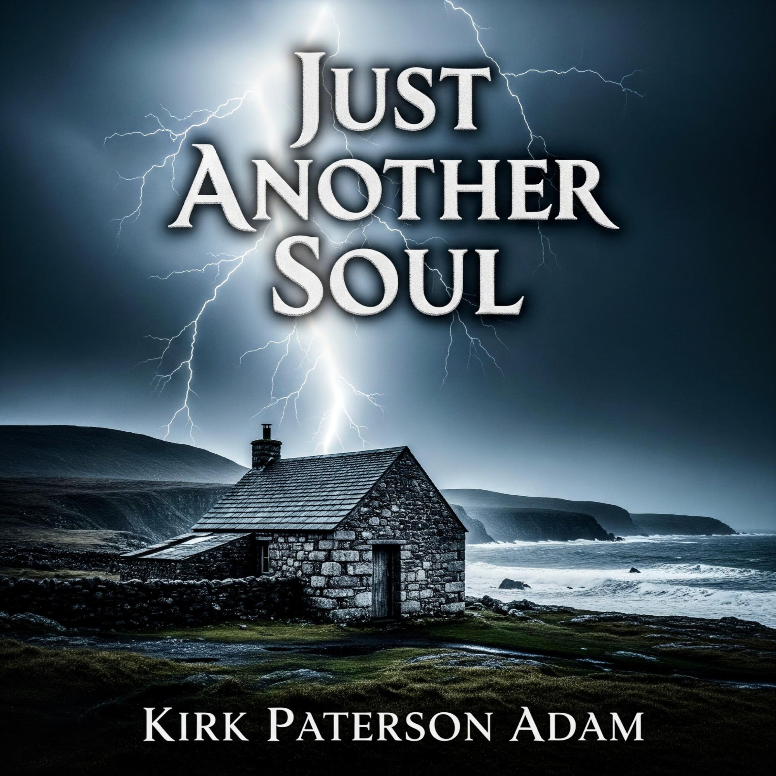Just Another Soul:
A man, broken and lost, journeys to the rugged Cornish coast, seeking solace in its dramatic cliffs and crashing waves. But instead of finding an end, he encounters an ethereal presence, a soul that intervenes and offers him a different path. This is a story of despair turned to hope, of finding light in the darkest corners, and unexpected encounters that can change a life forever.

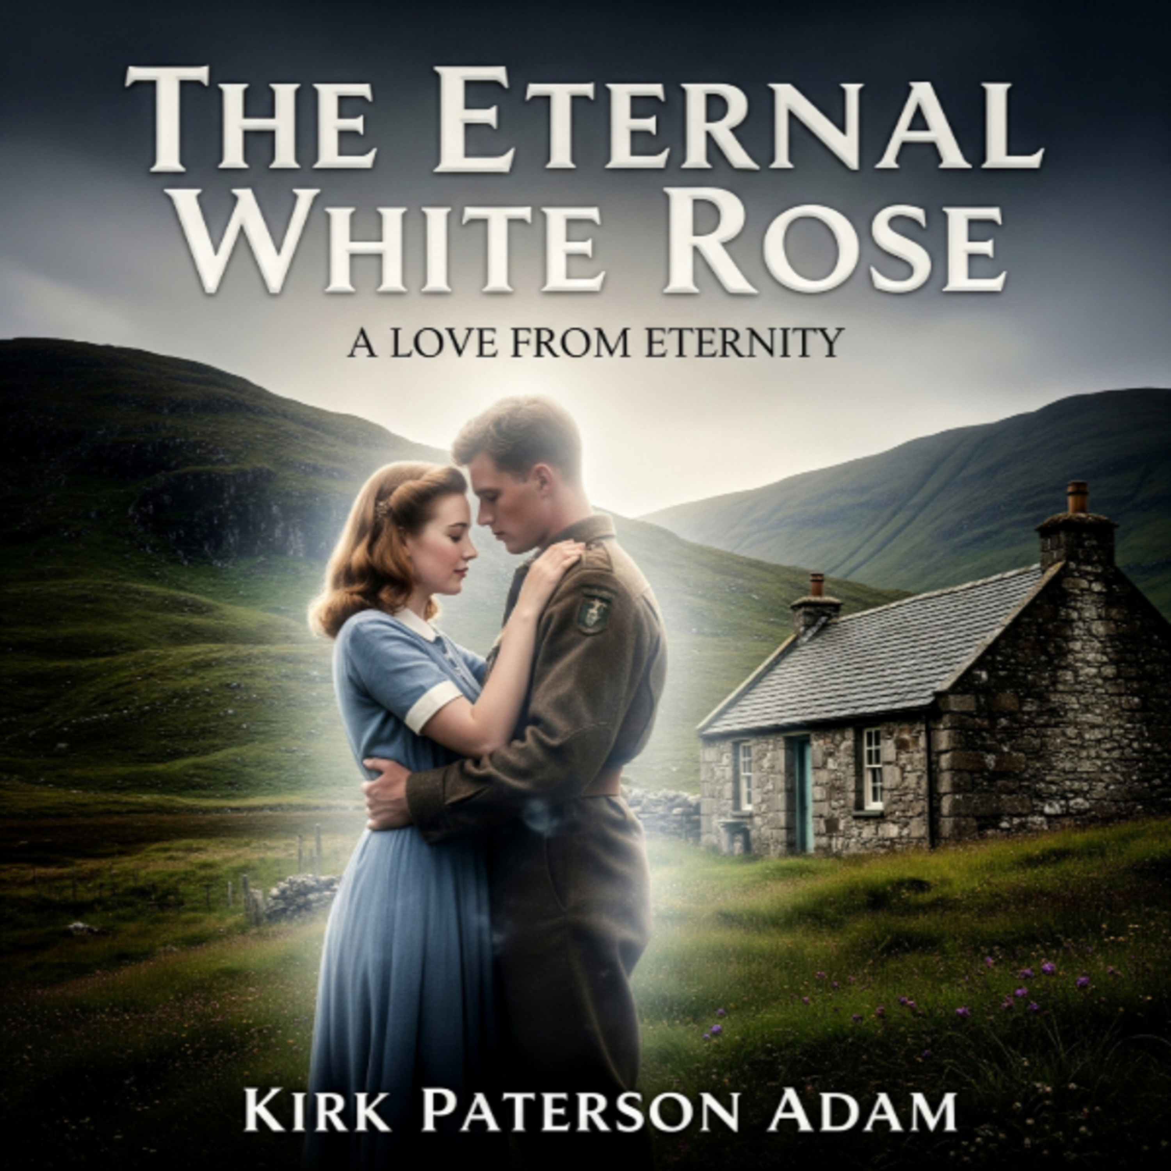The Eternal White Rose:

Eleanor lives a quiet life in her old Scottish home, but she's not alone. The spirit of James, a Great War soldier, haunts its ancient halls. As an impossible connection blossoms between them, she must confront a love that defies time and death. Can solace truly be found in the arms of a ghost? Dive into this wartime haunting tale of love beyond the grave, where two souls yearn for connection, as the boundaries between their two worlds collide.

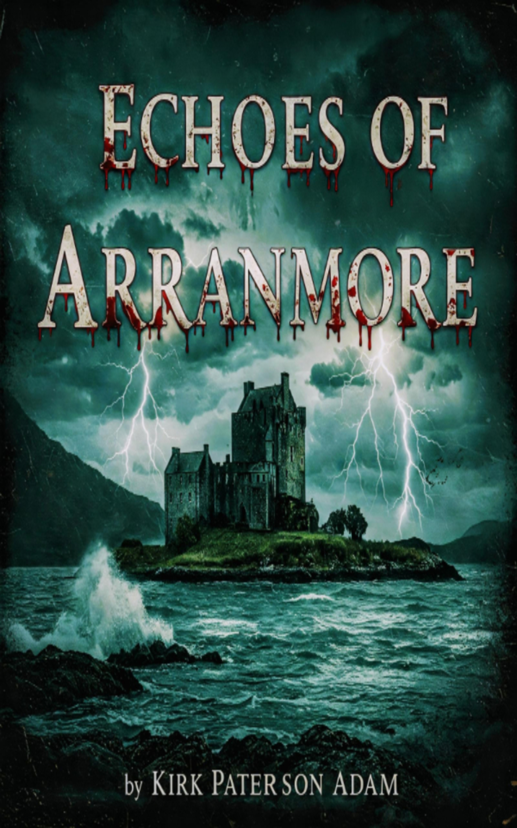Echoes Of Arranmore:

A couple venture into ancient Castle Arranmore, nestled on a remote Scottish island a short way off the rugged coast. Within its crumbling walls, they uncover terrifying secrets. Disturbing a sinister entity that lurks within the walls, plays havoc on their equipment during a paranormal investigation. What dark forces dwell within, and will they ever be allowed to leave the grip of Castle Arranmore?

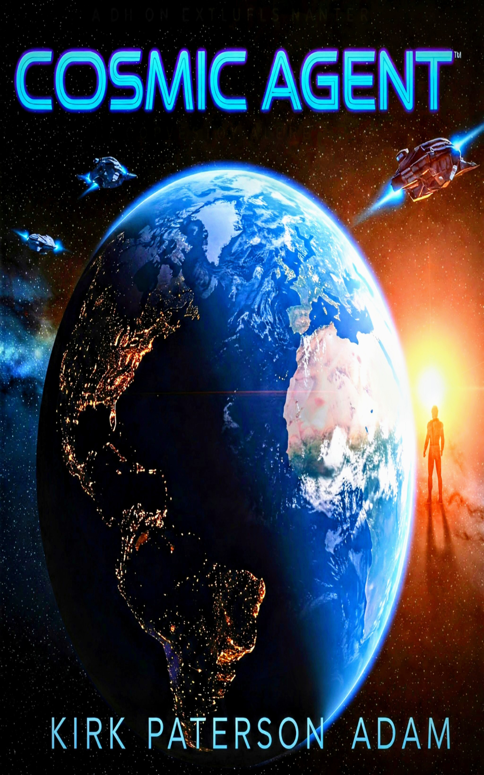Cosmic Agent:

In the bustling heart of London, an unlikely friendship blossoms between a couple and a mysterious stranger. Little do they know, their new friend is an alien agent, harbouring a secret that could change their lives forever. He's on the brink of calling in an invasion, but will their bond be strong enough to change his course? Cosmic Agent is a thrilling tale of friendship, deception and a battle for the fate of the Earth.

